Indicate whether the statement is true or false.

1. Does the following table match the equation: 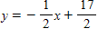?
2
3 | 7
6
8
​
 | a. | True
 | b. | False

2. Does the following table match the equation: 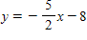?
-3
2 | 3
6 | -7
8 | -12
​
 | a. | True
 | b. | False

3. Does the following table match the equation: ?
0 | 9
4 | 7
8 | 5
12 | 3
​
 | a. | True
 | b. | False

4. Does the following table match the equation: 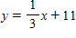?
3 | 12
5
6 | 13
9 | 14
​
 | a. | True
 | b. | False

5. Does the following table match the equation: ?
-3 | -4
-2 | -1
1 | 8
3 | 14
​
 | a. | True
 | b. | False

6. Does the following table match the equation: 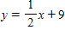?
-4 | -11
-2 | -10
0 | -9
2 | -8
​
 | a. | True
 | b. | False

Indicate whether the answer to the question is yes or no.

7. Is the following relation a function?
Number of soccer games played | Number of Goals scored
4 | 1
10 | 5
12 | 6
12 | 2
8 | 3
4 | 0

 | a. | Yes
 | b. | No

8. Is the following relation a function?
Age | Salary ($)
26 | 32,000
28 | 48,000
30 | 52,000
30 | 55,000
32 | 60,000
32 | 72,000

 | a. | Yes
 | b. | No

9. Is the following relation a function?
Year of Experience | Salary ($)
0 | 49,900
2 | 52,400
5 | 62,100
8 | 67,000
10 | 74,300
12 | 79,200

 | a. | Yes
 | b. | No

10. Is the following relation a function?
​
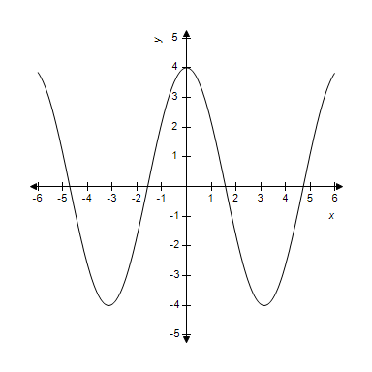
​
 | a. | Yes
 | b. | No

11. Is the following relation a function?
​
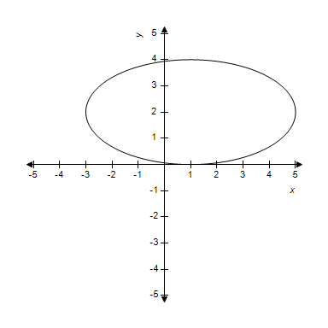
​
 | a. | Yes
 | b. | No

12. Is the following relation a function?
Number produced | Cost ($)
100 | 20
200 | 30
300 | 40
400 | 50
500 | 60
600 | 70

 | a. | Yes
 | b. | No

13. Is the following relation a function?
​
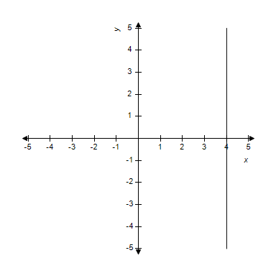
​
 | a. | Yes
 | b. | No

14. Is the following relation a function?
​
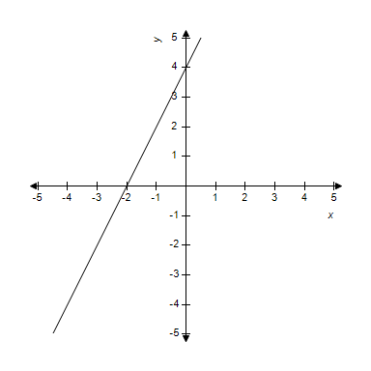
​
 | a. | Yes
 | b. | No

15. Is the following relation a function?
Year | Number of Deaths
1994 | 3,532
1995 | 3,262
1996 | 2,894
1997 | 2,601
1998 | 2,283
1999 | 2,093

 | a. | Yes
 | b. | No

16. Is the following relation a function?
​
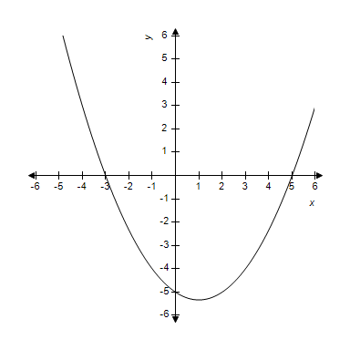
​
 | a. | Yes
 | b. | No

Enter the appropriate value to answer the question or solve the problem.

17.
​
__________
​

18.
​
__________

A real estate agent receives a salary of $11,000 plus 6% of her total sales for the year.

19. What will her pay be if she sells $823,000 worth of real estate for the year?
$ __________

Honey Yogurt has several costs of doing business. The owner pays $1,200 in rent and she pays $4,500 in salaries each month. Each yogurt sold costs her 85¢, but she sells it for $2.25.

20. How much profit will the yogurt shop owner make if 8,000 yogurts are sold?
$ __________

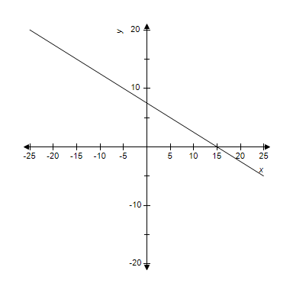
​
Use the graph to make estimates.

21. Estimate the input value that makes the output of the graph 17.5.

Use the graph to estimate the following.
​
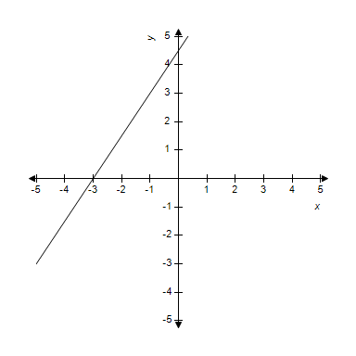

22. Estimate the value of x that results in .
​
__________

23.
​
__________

24.
​
__________

25.
​
__________

Use the graph to estimate the following.
​

26. Estimate the value of y when .
​
__________

The daily newspaper circulation in millions in the U.S. is given in the table.
Year | Daily Newspaper Circulation  (in millions)
1990 | 62.3
2000 | 55.8
2001 | 55.6
2002 | 55.2

27. Use your model to estimate the newspaper circulation in 1993. Round your answer to the nearest million.
approximately __________ million

A real estate agent receives a salary of $11,000 plus 6% of her total sales for the year.

28. How many dollars worth of real estate does she need to sell in order to make $176,000 for the year?
$ __________

The PTA at Magnolia Elementary has ordered spirit shirts for every student to wear on Fridays. For any orders of 100 or more, the silk screening company will charge $195 set up fee and $3 per T-shirt ordered.

29. How much did it cost the PTA to order 450 T-shirts, one per student?
$ __________

Honey Yogurt has several costs of doing business. The owner pays $1,200 in rent and she pays $4,500 in salaries each month. Each yogurt sold costs her 85¢, but she sells it for $2.25.

30. How many yogurts can she sell the first month she is open if the cost cannot exceed her initial budget of $12,000?
up to __________ yogurts

The PTA at Magnolia Elementary has ordered spirit shirts for every student to wear on Fridays. For any orders of 100 or more, the silk screening company will charge $195 set up fee and $3 per T-shirt ordered.

31. How many T-shirts could they order with a budget of $1,750?

32.
​
__________

33.
​
__________
​
​

34. A company that manufactures ink cartridges finds that they can sell cartridges each week at a price of dollars each, according to the formula
​
.
​
What price should they charge for each cartridge if they want to sell 600 cartridges each week?
​
$ __________

​
Use the graph to make estimates.

35. Estimate the input value that makes the output of this graph -2.5.

36. Estimate the output value of this graph when the input is 9.

The population of the Western United States in millions is given in the table.
Year | Western U.S. Population  (in millions)
2000 | 63.2
2001 | 64.51
2002 | 65.5
2003 | 66.47

37. Using your graphical model, estimate the population of the Western U.S. in 2006. Round your answer to the nearest million.
__________ million

Honey Yogurt has several costs of doing business. The owner pays $1,200 in rent and she pays $4,500 in salaries each month. Each yogurt sold costs her 85¢, but she sells it for $2.25.

38. How much revenue would the yogurt shop owner make if she sells 3,000 yogurts in one month?
$ __________

39.
​
__________

40. Air pollution in the United States has become a concern in recent years. The formula below models the sulfur dioxide emissions during a given year between 1970 and 1997.
​
​
In the formula, is the emission of sulfur dioxide in thousands of tons, and is the number of years after 1970; that is, on January 1, 1970. In what year were sulfur dioxide emissions 23,256 thousand tons?
(U.S. Environmental Protection Agency, National Air Quality and Emissions Trend Report.)

Honey Yogurt has several costs of doing business. The owner pays $1,200 in rent and she pays $4,500 in salaries each month. Each yogurt sold costs her 85¢, but she sells it for $2.25.

41. What will be the monthly cost if she sells 2,500 yogurts in a month?
$ __________

42.
​
__________

The population, , of Washington D.C. years past 2000 can be modeled by the equation:
​
​
where is in thousands.

43. Find the population of Washington D.C. in 2003.

The daily newspaper circulation in millions in the U.S. is given in the table.
Year | Daily Newspaper Circulation  (in millions)
1990 | 62.3
2000 | 55.8
2001 | 55.6
2002 | 55.2

44. Use your model to estimate newspaper circulation in 1984. Round your answer to one decimal place.
approximately __________ million

45. 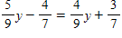
​
__________

Honey Yogurt has several costs of doing business. The owner pays $1,200 in rent and she pays $4,500 in salaries each month. Each yogurt sold costs her 85¢, but she sells it for $2.25.

46. How many yogurts must the owner sell in one month in order to break even?

The fall high school (9th-12th grades) enrollment for the U.S. in millions is given in the table.
Year | Fall High School Enrollments  (in millions)
2000 | 14.8
2001 | 15.1
2002 | 15.3
2003 | 15.6

47. According to your model, when will the fall high school enrollment reach approximately 16.1 million students? Enter the year whose enrollment is closest to the desired value.

48. In what year will the population be approximately 549,000?

49. Determine the slope and y-intercept of the following linear equation:
​
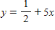

A loan officer makes $300 per week base salary plus 2% commission on every loan amount he closes.

50. Write an equation for the loan officer’s salary, , per week when he closes dollars in home loans.

A preschool has an enrollment fee of $350 and then tuition is $275 a month.

51. Write an equation for the tuition, , of the preschool for how many months, , a child attends.

52. Find an equation for a model of the given data.
2 | 286.3
3 | 454.4
4 | 605
5 | 775.4

53. Determine the slope and y-intercept of the following linear equation:
​
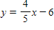

A business card company charges a $200 set fee and $0.10 per card for printing.

54. Using the total price equation for the business cards, find the slope of the equation.
Explain its meaning in regard to the total price.
When does the model breakdown or not make sense?

55. a) Estimate .
b) Estimate such that .
c) Give the domain and range for .
d) Estimate the vertical and horizontal intercepts for .
​
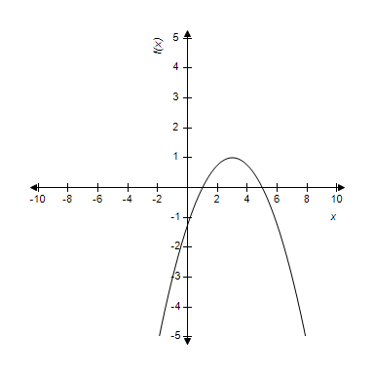
​

56. Graph the line using any method. Label the vertical and horizontal intercepts.
​
​
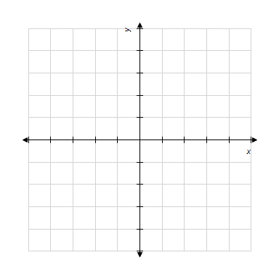

The cost to produce a custom-printed keychain is given in the table.
Keychain | Cost ($)
100 | 90
200 | 125
300 | 160
400 | 195
500 | 230

57. Find . Explain the meaning in this situation.

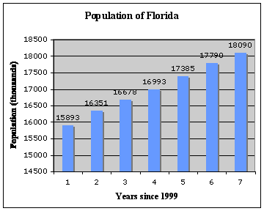

58. Give a reasonable domain and range for this model.

59. Complete the table for the following equation, then graph by plotting the points.
Be sure to label your axes.
​
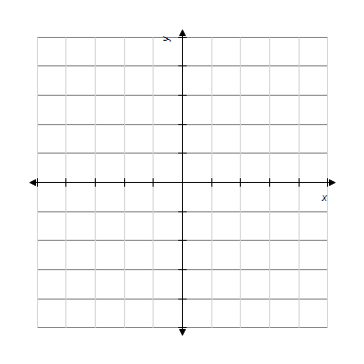
​

60. Find an equation for a model of the given data.
100 | 90
200 | 125
1,000 | 405
3,000 | 1,105

Use the graph to estimate the following.
​

61. Estimate the x-intercept. Write it as a point .

A preschool has an enrollment fee of $350 and then tuition is $275 a month.

62. Using the tuition equation for the preschool, find the slope of the equation.
Explain its meaning in regard to the total tuition paid.
When does the model breakdown or not make sense?

63. Determine the slope and y-intercept of the following linear equation:
​

64. A loan officer earns $150 commission for the number of loans, that she closes per month in addition to the $1,850 base monthly salary, .
​
a. Write an equation representing her monthly salary in terms of how many loans she closes.
​
b. Find the -intercept and interpret the intercept in terms of the information given in the problem.
​
c. Find the -intercept and interpret the intercept in terms of the information given in the problem.

The fall high school (9th-12th grades) enrollment for the U.S. in millions is given in the table.
Year | Fall High School Enrollments  (in millions)
2000 | 14.8
2001 | 15.1
2002 | 15.3
2003 | 15.6

65. What information does your model give for the year 1998?

66. The cost in dollars a T-shirt company charges for an order of n T-shirts is a $100 set up fee and $4 per shirt ordered.
​
a. Write an equation representing the cost, , in terms of the number of T-shirts ordered.
​
b. Find the -intercept and interpret the intercept in terms of the information given in the problem.
​
c. Find the -intercept and interpret the intercept in terms of the information given in the problem.

67. Graph the line using any method. Label the vertical and horizontal intercepts.
​
​

68. What is the vertical intercept for this model?
What does it mean in this situation?

A loan officer makes $300 per week base salary plus 2% commission on every loan amount he closes.

69. Create a graph for the equation using your points.
Remember to label your graph with units and label both axes.
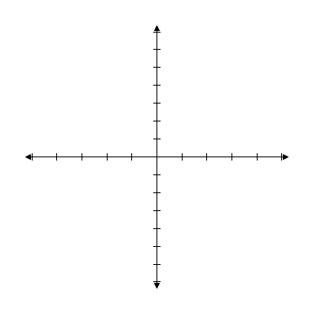
​

Honey Yogurt has several costs of doing business. The owner pays $1,200 in rent and she pays $4,500 in salaries each month. Each yogurt sold costs her 85¢, but she sells it for $2.25.

70. Write an equation for the total cost, , of running the yogurt shop for a month depending on the number of yogurts, , she sells.

71. 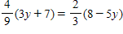

72. List the domain and range of the relation.
Year | Number of Deaths
1994 | 3,532
1995 | 3,262
1996 | 2,894
1997 | 2,601
1998 | 2,283
1999 | 2,093

73. Use the graph to find the following.
​
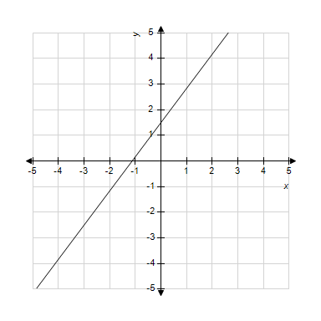
​
a. Find the slope of the line.
b. Is the line increasing or decreasing?
c. Estimate the vertical intercept.
d. Estimate the horizontal intercept.
​

74. Determine the slope and y-intercept of the following linear equation:
​

75. Find an equation for a model of the given data.
10 | 252.5
20 | 265
50 | 302.5
100 | 365

76. Find the intercepts and graph the line of the following equation. Label the vertical and horizontal intercepts on the graph.
​
​
​

77. Find the intercepts and graph the line of the following equation. Label the vertical and horizontal intercepts on the graph.
​
​

78. Determine the slope and y-intercept of the following linear equation:
​

79. Graph the line using any method. Label the vertical and horizontal intercepts.
​
​
​

The population of the Western United States in millions is given in the table.
Year | Western U.S. Population  (in millions)
2000 | 63.2
2001 | 64.51
2002 | 65.5
2003 | 66.47

80. What is the vertical intercept for your model and what does it mean in this context?

Year | Gross Profit  (in millions of $)
2002 | 37
2003 | 47
2004 | 61
2005 | 75
2006 | 84

81. Find such that . Interpret its meaning.

82. A sales clerk’s pay at an electronics store consists of $300 base salary plus a 4% commission on all her sales for the week.
​
a. Write an equation that represents her pay, , in terms of her sales, .
​
b. Find the -intercept and interpret the intercept in terms of the information given in the problem.
​
c. Find the -intercept and interpret the intercept in terms of the information given in the problem.

83. Find an equation for a model of the given data.
4 | 3,532
6 | 2,894
8 | 2,283
9 | 1,950

84. Complete the table for the following equation, then graph by plotting the points.
Be sure to label your axes.
​
​
​

The population of the Western United States in millions is given in the table.
Year | Western U.S. Population  (in millions)
2000 | 63.2
2001 | 64.51
2002 | 65.5
2003 | 66.47

85. Create a hand drawn scattergram for this data and draw an “eyeball best fit” line through the data. Each vertical gridline represents an increase of one year of time.
​
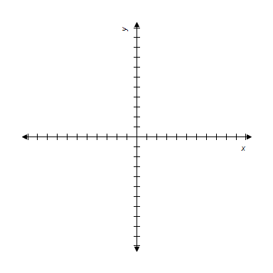

86. Complete the table for the following equation, then graph by plotting the points.
Be sure to label your axes.
x | y
​
​

87.
​
a) Find .
b) Find such that .
c) Give the domain and range for .
​

88. A loan officer’s total salary consists of a base commission of $1,200 per month plus a 3% commission for the amount of the loans he closes during the month. His salary can represented by the equation:
​
​
a. Find the -intercept and interpret the intercept in terms of the information given in the problem.
​
b. Find the -intercept and interpret the intercept in terms of the information given in the problem.

The fall high school (9th-12th grades) enrollment for the U.S. in millions is given in the table.
Year | Fall High School Enrollments  (in millions)
2000 | 14.8
2001 | 15.1
2002 | 15.3
2003 | 15.6

89. Let represent the fall high school enrollment (in millions), years since 2000. Create a graphical model for this data. Each vertical gridline represents an increase of one year of time.

90. Write the equation of the line that goes through the point and is parallel to the line .

The cost to produce a custom-printed keychain is given in the table.
Keychain | Cost ($)
100 | 90
200 | 125
300 | 160
400 | 195
500 | 230

91. Find such that and interpret the result.

92. Graph the line using any method. Label the vertical and horizontal intercepts.
​
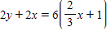
​

93.

94. Find the intercepts and graph the line of the following equation. Label the vertical and horizontal intercepts on the graph.
​
​

Year | Gross Profit  (in millions of $)
2002 | 37
2003 | 47
2004 | 61
2005 | 75
2006 | 84

95. Find an equation for a model of these data. Write your model in function notation.
Define as the number of years since 2000, and as the profit of the company.

96. Use the graph to find the following.
​
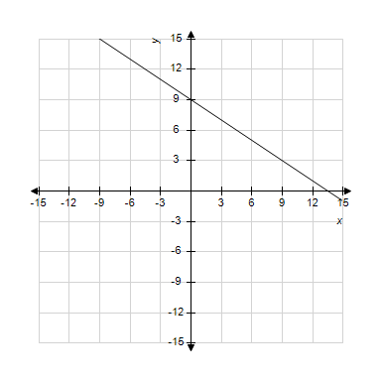
​
a. Find the slope of the line.
b. Is the line increasing or decreasing?
c. Estimate the vertical intercept.
d. Estimate the horizontal intercept.
​

​
Use the graph to make estimates.

97. Estimate the vertical intercept. Write it as a point .

98. Find an equation for a model of the given data.
4 | 24.5
5 | 25.4
6 | 26.4
7 | 26.7

99. a) Estimate .
b) Estimate such that .
c) Give the domain and range for .
d) Estimate the vertical and horizontal intercepts for .
​
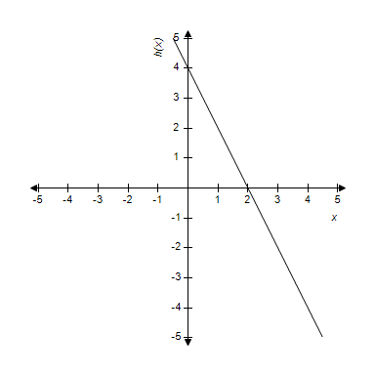
​

100. Use the graph to find the following.
​
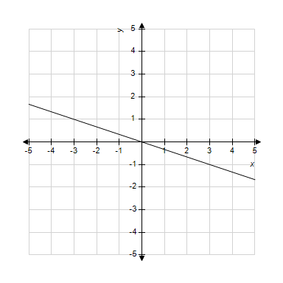
​
​
a. Find the slope of the line.
b. Is the line increasing or decreasing?
c. Estimate the vertical intercept.
d. Estimate the horizontal intercept.
​
​

101. The cost in dollars to rent a 17’ Uhaul truck and to drive it miles is represented by the equation:
​
​
a. Find the -intercept and interpret the intercept in terms of the information given in the problem.
​
b. Find the -intercept and interpret the intercept in terms of the information given in the problem.
​

102. Write the equation of the line that goes through the point 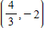 and is parallel to the line .

103. Find the intercepts and graph the line of the following equation. Label the vertical and horizontal intercepts on the graph.
​
​

104. Find an equation for a model of the given data.
4 | 930
5 | 1,134
6 | 1,333
7 | 1,532

​
Use the graph to make estimates.

105. Estimate the horizontal intercept. Write it as a point .

106. a) Estimate .
b) Estimate such that .
c) Give the domain and range for .
d) Estimate the vertical and horizontal intercepts for .
​
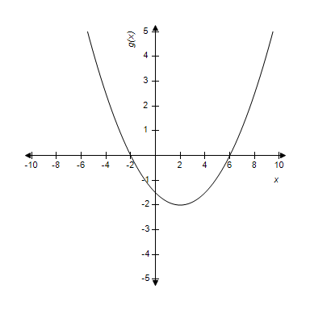
​

The amount teachers are paid per year is typically determined by their years of experience. The salaries for several different teachers at one school district are given in the table.
Experience (Years) | Salary (dollars)
0 | 49,900
2 | 52,400
5 | 62,100
8 | 67,000
10 | 74,300
12 | 79,200

107. According to this model what is the expected salary of a teacher with 15 years experience.

108. List the domain and range of the relation.
Number of soccer games played | Number of Goals  scored
4 | 1
10 | 5
12 | 6
12 | 2
8 | 3
4 | 0

109. Use the graph to the find the following.
​
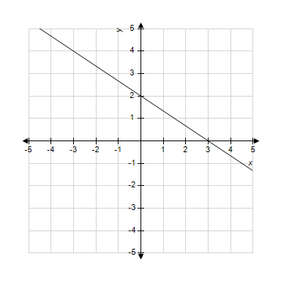
​
a. Find the slope of the line.
b. Is the line increasing or decreasing?
c. Estimate the vertical intercept.
d. Estimate the horizontal intercept.
​
​

110. Graph the line using any method. Label the vertical and horizontal intercepts.
​
​

111. Complete the table for the following equation, then graph by plotting the points.
Be sure to label your axes.
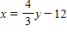
​
​

112. Find an equation for a model of the given data.
2 | 3.53
3 | 3.26
4 | 2.89
5 | 2.60

113. Complete the table for the following equation, then graph by plotting the points.
Be sure to label your axes.
​
​

114. In 1990, the U.S. Census Bureau reported that 8% of the California population were children under five years old. In 2000, 7.3% of the California population was made up of children under five years old.
​
a. Assuming that the percentage of Californians under five years old continues at a constant rate, write a linear equation that represents the percent of Californians under five years old, years after 1990.
b. Find the slope of the equation and give its meaning in this situation.
c. Find the vertical intercept for the equation and give its meaning in this situation.
d. Find the horizontal intercept for the equation and give its meaning in this situation.

115. Write the equation of the line that goes through the point and is perpendicular to the line .

116. Find the intercepts and graph the line of the following equation. Label the vertical and horizontal intercepts on the graph.
​
​

117. What is the slope of this model? Explain its meaning in this situation.

Year | Gross Profit  (in millions of $)
2002 | 37
2003 | 47
2004 | 61
2005 | 75
2006 | 84

118. Find . Explain the meaning in this situation.

119. Complete the table for the following equation, then graph by plotting the points.
Be sure to label your axes.
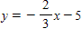
​
​

120. Determine the slope and y-intercept of the following linear equation:
​

121. Find the intercepts and graph the line of the following equation. Label the vertical and horizontal intercepts on the graph.
​
​
​

Use the graph to estimate the following.
​

122. Estimate the y-intercept. Write it as a point .

Home Depot’s net sales are given in the bar graph.
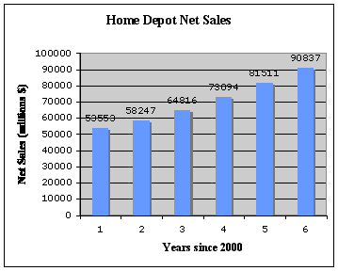

123. Find an equation for a model of these data.

124. 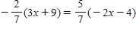

The amount teachers are paid per year is typically determined by their years of experience. The salaries for several different teachers at one school district are given in the table.
Experience (Years) | Salary (dollars)
0 | 49,900
2 | 52,400
5 | 62,100
8 | 67,000
10 | 74,300
12 | 79,200

125. How many years experience would a teacher need to make $72,000?

126. The population of the United States can be represented by the equation:
​
​
where is the number of years since 2000 and is the population in millions.
Source: U.S. Census Bureau
​
a. Find the -intercept and interpret the intercept in terms of the information given in the problem.
​
b. Find the -intercept and interpret the intercept in terms of the information given in the problem. Round your answer to two decimal places.

127. Find the intercepts and graph the line of the following equation. Label the vertical and horizontal intercepts on the graph.
​
​

A business card company charges a $200 set fee and $0.10 per card for printing.

128. Create a table of points that satisfy the equation you found.

129. A loan officer makes a base salary of $1,500 per month. If a loan officer closes two loans in the month, he will earn a total of $2,000 for the month. If he closes six loans, he will earn a total of $3,000 for the month.
​
a. Write an equation of the line for the total salary a loan officer can make if he closes loans.
b. Find the slope of the equation and give its meaning in this situation.
c. Find the vertical intercept for the equation and give its meaning in this situation.
d. Find the horizontal intercept for the equation and give its meaning in this situation.

130. Graph the line using any method. Label the vertical and horizontal intercepts.
​
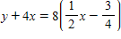
​

131. Write the equation of the line that goes through the point and is perpendicular to the line .

The cost to produce a custom-printed keychain is given in the table.
Keychain | Cost ($)
100 | 90
200 | 125
300 | 160
400 | 195
500 | 230

132. What is the -intercept for this model? What does it mean in this situation?

The amount teachers are paid per year is typically determined by their years of experience. The salaries for several different teachers at one school district are given in the table.
Experience (Years) | Salary (dollars)
0 | 49,900
2 | 52,400
5 | 62,100
8 | 67,000
10 | 74,300
12 | 79,200

133. Give a reasonable domain and range for this model.

134. A dump truck contains 8,500 pounds of fill dirt, . It can unload at a rate of 100 pounds per minute, .
​
a. Write an equation representing how many pounds of fill dirt are in the truck minutes after the truck has started dumping its load.
​
b. Find the -intercept and interpret the intercept in terms of the information given in the problem.
​
c. Find the -intercept and interpret the intercept in terms of the information given in the problem.

135. The death rate (per 100,000 people) for heart disease in the United States can be represented by the equation:
​
​
where is the rate of death years after the year 2000.
Source: Centers for Disease Control and Prevention
​
a. Find the -intercept and interpret the intercept in terms of the information given in the problem.
​
b. Find the -intercept and interpret the intercept in terms of the information given in the problem. Round your answer to two decimal places.

Home Depot’s net sales are given in the bar graph.

136. According to this model what would be the estimated net sales in 2010?

137. List the domain and range of the relation.
​
​

138. Determine the slope and y-intercept of the following linear equation:
​

139. Graph the line using any method. Label the vertical and horizontal intercepts.
​
​

140. The percentage of restaurants that are still in business years after the first year in operation can be represented by the equation .
​
a. Find the slope of the equation and give its meaning in this situation.
b. Find the vertical intercept for the equation and give its meaning in this situation.
c. Find the horizontal intercept for the equation and give its meaning in this situation.

The expected number of years more a person will live at any given age , is represented by the simplified equation:
​
​
Source: Statistical Abstract of the U.S.

141. Create a graph for the equation using your points.
Remember to label your graph with units and label both axes.
​
​
​
​

142. Find an equation for a model of the given data.
0 | 282.2
1 | 285.1
2 | 288
3 | 290.9

143. Graph the line using any method. Label the vertical and horizontal intercepts.
​
​

144. In the state of California, the percentage of families with children under five years old who were living below the poverty level went from 15.9% in 2006 to 17.9% in 2009.
​
Source: U.S. Census Bureau
​
a. Assuming the percentage of families with children under five who are living below the poverty level has been changing at a constant rate since 2000, write an equation representing this information.
b. Find the slope of the equation and give its meaning in this situation.
c. Find the vertical intercept for the equation and give its meaning in this situation.
d. Find the horizontal intercept for the equation and give its meaning in this situation.

A real estate agent receives a salary of $11,000 plus 6% of her total sales for the year.

145. Write an equation that expresses the agent’s salary, , in terms of her total annual sales, .

146. Use the graph to find the following.
​
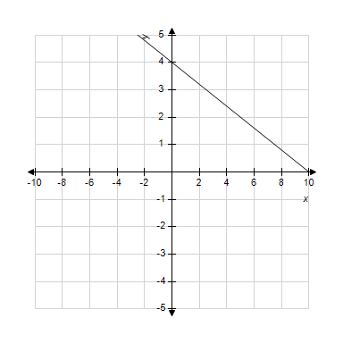
​
a. Find the slope of the line.
b. Is the line increasing or decreasing?
c. Estimate the vertical intercept.
d. Estimate the horizontal intercept.
​
​

The expected number of years more a person will live at any given age , is represented by the simplified equation:
​
​
Source: Statistical Abstract of the U.S.

147. Using the expected years equation, find the slope of the equation.
Explain its meaning in regard to the number of years more a person is expected to live.
When does the model breakdown or not make sense?

A loan officer makes $300 per week base salary plus 2% commission on every loan amount he closes.

148. Create a table of points that satisfy the equation you found. (Hint: remember to use amounts that would make sense with the price of a home)

149. Write the equation of the line that goes through the point and is perpendicular to the line .

The daily newspaper circulation in millions in the U.S. is given in the table.
Year | Daily Newspaper Circulation  (in millions)
1990 | 62.3
2000 | 55.8
2001 | 55.6
2002 | 55.2

150. What information does your model give for the year 2005?

151. Nancy teaches piano for $27 for each 1-hour lesson. She rents a studio for the semester for $950. So her profit can be represented by the equation: , where is how many 1-hour lessons she teaches throughout the semester.
​
a. Find the slope of the equation and give its meaning in this situation.
b. Find the vertical intercept for the equation and give its meaning in this situation.
c. Find the horizontal intercept for the equation and give its meaning in this situation.
d. If she taught 10 kids a 1-hour lesson every week for the 18-week semester, what would her profit be?

The amount teachers are paid per year is typically determined by their years of experience. The salaries for several different teachers at one school district are given in the table.
Experience (Years) | Salary (dollars)
0 | 49,900
2 | 52,400
5 | 62,100
8 | 67,000
10 | 74,300
12 | 79,200

152. Find an equation for a model of these data.

A business card company charges a $200 set fee and $0.10 per card for printing.

153. Create a graph for the equation using your points.
Remember to label your graph with units and label both axes.
​
​
​

154. 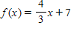
​
a) Find .
b) Find x such that .
c) Give the domain and range for .
​

A business card company charges a $200 set fee and $0.10 per card for printing.

155. Write an equation for the price the company charges when someone orders cards.

156. 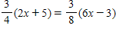

157. Use the graph to the find the following.
​
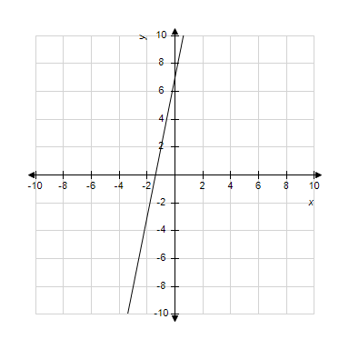
​
a. Find the slope of the line.
b. Is the line increasing or decreasing?
c. Estimate the vertical intercept.
d. Estimate the horizontal intercept.
​
​

158. Find an equation for a model of the given data.
20 | 58.4
30 | 48.9
40 | 39.5
50 | 30.6

159. Determine the slope and y-intercept of the following linear equation:
​

The cost to produce a custom-printed keychain is given in the table.
Keychain | Cost ($)
100 | 90
200 | 125
300 | 160
400 | 195
500 | 230

160. Find an equation for a model of these data. Write the model in function notation.
Define as the cost to produce keychains.

Honey Yogurt has several costs of doing business. The owner pays $1,200 in rent and she pays $4,500 in salaries each month. Each yogurt sold costs her 85¢, but she sells it for $2.25.

161. Write an equation for the profit, , made the yogurt shop owner depending on how many yogurts are sold in a month.

The daily newspaper circulation in millions in the U.S. is given in the table.
Year | Daily Newspaper Circulation  (in millions)
1990 | 62.3
2000 | 55.8
2001 | 55.6
2002 | 55.2

162. Let represent the daily newspaper circulation (in millions) years since 1990 (corresponds to 1990). Create a graphical model for this data.
​

163. Find the intercepts and graph the line of the following equation. Label the vertical and horizontal intercepts on the graph.
​
​

164. Estimate the population of Florida in 2012.

165. Graph the line using any method. Label the vertical and horizontal intercepts.
​
​

166. List the domain and range of the relation.
​
​

167. Find the intercepts and graph the line of the following equation. Label the vertical and horizontal intercepts on the graph.
​
​

168. Complete the table for the following equation, then graph by plotting the points.
Be sure to label your axes.
​
​

169. The taximeter was invented in 1891 by Wilhelm Bruhn. The city of Chicago charges $1.80 plus $0.40 per mile for a taxi ride. A woman paid a fare of $9.80. Write an equation that connects the fare the woman paid, the miles she traveled, , and the charges the taximeter computes.

170. a) Estimate .
b) Estimate such that .
c) Give the domain and range for .
d) Estimate the vertical and horizontal intercepts for .
​
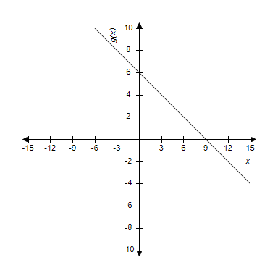
​

171.
​
a) Find .
b) Find such that .
c) Give the domain and range for .
​

172. A non-California resident attending a California State University must pay a tuition of $2,000 per quarter plus a fee of $248 per quarter unit.
​
a. Write an equation for the total tuition, , in terms of the number of units, , a student takes.
​
b. Find the -intercept and interpret the intercept in terms of the information given in the problem.
​
c. Find the -intercept and interpret the intercept in terms of the information given in the problem.

The PTA at Magnolia Elementary has ordered spirit shirts for every student to wear on Fridays. For any orders of 100 or more, the silk screening company will charge $195 set up fee and $3 per T-shirt ordered.

173. Write an equation for the total cost, , of making T-shirts.

174. 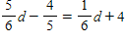

175. Find the intercepts and graph the line of the following equation. Label the vertical and horizontal intercepts on the graph.
​
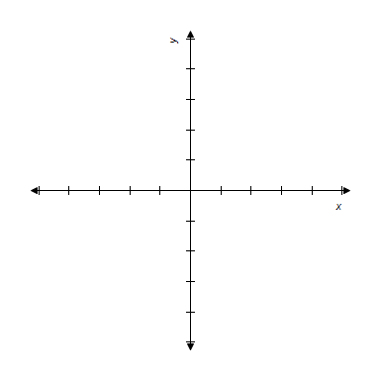
​
​

Year | Gross Profit  (in millions of $)
2002 | 37
2003 | 47
2004 | 61
2005 | 75
2006 | 84

176. What is the P-intercept for this model? What does it mean in this situation?

Honey Yogurt has several costs of doing business. The owner pays $1,200 in rent and she pays $4,500 in salaries each month. Each yogurt sold costs her 85¢, but she sells it for $2.25.

177. Write an equation for the total revenue, , from running the yogurt shop for a month depending on the number of yogurts, , that she sells.

178. Find an equation for a model of the given data.
1 | 3.7
3 | 2.6
4 | 1.9
6 | 1.2

A preschool has an enrollment fee of $350 and then tuition is $275 a month.

179. Create a table of points that satisfy the equation you found. (Hint: remember to use amounts that would make sense with the number of months)

Home Depot’s net sales are given in the bar graph.

180. What is the vertical intercept for this model? Explain its meaning in this situation.

181. Determine the slope and y-intercept of the following linear equation:
​

A preschool has an enrollment fee of $350 and then tuition is $275 a month.

182. Create a graph for the equation using your points.
Remember to label your graph with units and label both axes.
​
​
​
​

183. Complete the table for the following equation, then graph by plotting the points.
Be sure to label your axes.
​
​

A loan officer makes $300 per week base salary plus 2% commission on every loan amount he closes.

184. Using the salary equation for the loan officer, find the slope of the equation.
Explain its meaning in regard to the salary of the loan officer.
When does this model breakdown or not make sense?

185. Write the equation of the line that goes through the point and is parallel to the line .

186.
​
a) Find .
b) Find such that .
c) Give the domain and range for .

187. The number of deaths induced by illegal drugs of women in the United States can be represented by the equation:
​
​
where is the number of years since 2000 and is the total number of deaths.
Source: Centers for Disease Control and Prevention
​
a. Find the -intercept and interpret the intercept in terms of the information given in the problem.
​
b. Find the -intercept and interpret the intercept in terms of the information given in the problem. Round your answer to two decimal places.

The amount teachers are paid per year is typically determined by their years of experience. The salaries for several different teachers at one school district are given in the table.
Experience (Years) | Salary (dollars)
0 | 49,900
2 | 52,400
5 | 62,100
8 | 67,000
10 | 74,300
12 | 79,200

188. What is the slope of this model? Explain its meaning in this situation.

The expected number of years more a person will live at any given age , is represented by the simplified equation:
​
​
Source: Statistical Abstract of the U.S.

189. Create a table of points that satisfy the equation you found.

190. Determine the slope and y-intercept of the following linear equation:
​
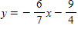

Year | Gross Profit  (in millions of $)
2002 | 37
2003 | 47
2004 | 61
2005 | 75
2006 | 84

191. Give a reasonable domain and range for this model.

192. a) Estimate .
b) Estimate such that .
c) Give the domain and range for .
d) Estimate the vertical and horizontal intercepts for .
​
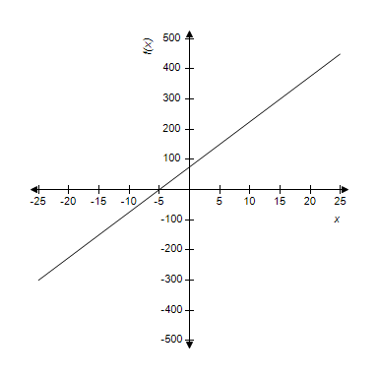
​

193. Find an equation for a model of these data.

The cost to produce a custom-printed keychain is given in the table.
Keychain | Cost ($)
100 | 90
200 | 125
300 | 160
400 | 195
500 | 230

194. Give a reasonable domain and range for this model.

195. What is the horizontal intercept for this model?
What does it mean in this situation?

Home Depot’s net sales are given in the bar graph.

196. What is the slope of this model? Explain its meaning in this situation.

197. Graph the line using any method. Label the vertical and horizontal intercepts.
​
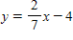
​

The population of the Western United States in millions is given in the table.
Year | Western U.S. Population  (in millions)
2000 | 63.2
2001 | 64.51
2002 | 65.5
2003 | 66.47

198. Adjust the data for the given information in the following table.
​  Years since 2000, | Western U.S.  Population,  (in millions)
​

199.
​
a) Find .
b) Find such that .
c) Give the domain and range for .

Indicate the answer choice that best completes the statement or answers the question.

Hertz Truck Rentals offers a midweek special on all of their truck rentals. To rent a 15-foot truck for one day, it will cost $29.66 plus $0.68 per mile driven. Let be the cost of renting a 15-ft truck from Hertz for one day and driving the truck, , miles.

200. How many miles could you drive the truck for the one day if you could only pay $79? Please round the answer to the nearest mile.
​
 | a. | 70 miles | b. | 71 miles
 | c. | 72 miles | d. | 73 miles

The worldwide sales from prescription drugs used in the treatment of the blood disorder hemophilia (in millions of $) is given in the table.

Year | Treatment Sales (in millions of $)
2001 | 2,584
2002 | 2,932.7
2003 | 3,264.7
2004 | 3,598.2

201. Estimate the vertical intercept.
​
 | a. |  | b.
 | c. |  | d.

202. Which of the following is a function?
​
 | a. | weight of a person who is height | b. | height of a person who is years old
 | c. | weight of a person days after beginning to exercise | d. | height of a child in grade

2003 | 21.5
2004 | 22.3
2005 | 23.4
2006 | 24.6

203. Give a reasonable -scale and -scale for the given data.
​
 | a. | , | b. | ,
 | c. | , | d. | ,

204. Determine if the following points pass through the same line, by determining if the slope is consistent.
​
-2 | -3
-1
1
2 | 5
​
 | a. | they do not pass through the same line | b. | yes; slope
 | c. | yes; slope | d. | yes; slope

205. Rewrite the following equation in the general form of a line.
​
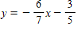
​
 | a. |  | b.
 | c. |  | d.

206. Which of the following is NOT a function?
​
 | a. |  | b.
 | c. |  | d.

The worldwide sales from prescription drugs used in the treatment of the blood disorder hemophilia (in millions of $) is given in the table.

Year | Treatment Sales (in millions of $)
2001 | 2,584
2002 | 2,932.7
2003 | 3,264.7
2004 | 3,598.2

207. Interpret the meaning of the vertical intercept.
​
 | a. | In the year 2000, the treatment sales were $2,250 million. | b. | In year 0, the treatment sales were $2.
 | c. | In the year 2000, the treatment sales were $2 billion. | d. | In the year 2000, the treatment sales were $750 million.

208. Determine if the following points pass through the same line, by determining if the slope is consistent.
​
-2 | 8
0 | 1
1 | -1
2 | -8
​
 | a. | they do not pass through the same line | b. | yes; slope
 | c. | yes; slope | d. | yes; slope

209. Write the equation of the line with the slope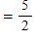 and passing through the point .
​
 | a. |  | b.
 | c. |  | d.

210. Write the equation for the line shown in the graph. Give your answer in slope-intercept form and use points that cross clearly on the graph.
​
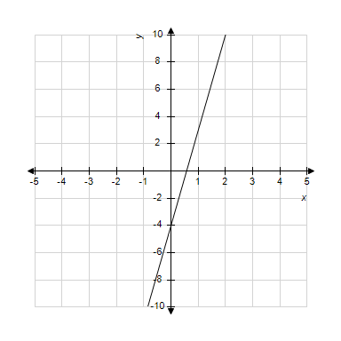
​
 | a. |  | b.
 | c. |  | d.

211. On October 31, Jane and Jack fill their 280-gallon heating fuel oil tank. Beginning in November they use an average of 15 gallons of heating fuel oil per week. Write an equation that expresses the amount of oil, , in the tank in terms of the number of weeks, , since October 31.
​
 | a. |  | b.
 | c. |  | d.

The worldwide sales from prescription drugs used in the treatment of the blood disorder hemophilia (in millions of $) is given in the table.

Year | Treatment Sales (in millions of $)
2001 | 2,584
2002 | 2,932.7
2003 | 3,264.7
2004 | 3,598.2

212. Which of the following scatterplots could represent the data in the given table?
​
 | a. | ​ | b. | ​
 | c. | ​ | d. | ​

213. Rewrite the following equation in the general form of a line.
​
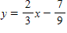
​
 | a. |  | b.
 | c. |  | d.

214. Write the equation for the line shown in the graph. Give your answer in slope-intercept form and use points that cross clearly on the graph.
​
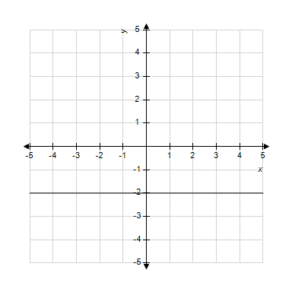
​
 | a. |  | b.
 | c. |  | d.

215. Determine if the following points pass through the same line, by determining if the slope is consistent.
​
-2 | 5.8
-1 | 5.4
0 | 5
1 | 4.6
​
 | a. | they do not pass through the same line | b. | yes; slope
 | c. | yes; slope | d. | yes; slope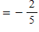

216. Write the equation for the line shown in the graph. Give your answer in slope-intercept form and use points that cross clearly on the graph.
​
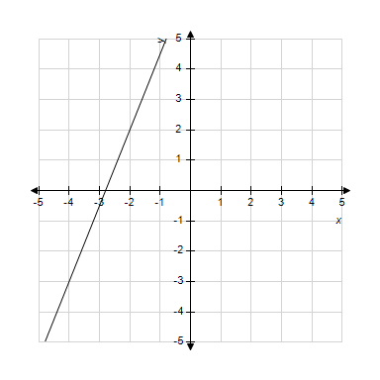
​
 | a. |  | b.
 | c. |  | d.

217. Determine if the following points pass through the same line, by determining if the slope is consistent.
​
-4 | -8
-1 | 1
1 | 7
2 | 10
​
 | a. | they do not pass through the same line | b. | yes; slope
 | c. | yes; slope | d. | yes; slope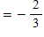

The elementary school expenditures, , in the U.S. in billions of dollars years past 1990 can be modeled by the equation:
​

218. What was the expenditure in billions of dollars for U.S. elementary schools in 2003?
​
 | a. | $389.9 billion | b. | $392.5 billion
 | c. | $286.9 billion | d. | $380 billion

219. Write the equation of the line with the slope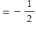 and passing through the point .
​
 | a. |  | b.
 | c. |  | d.

Air pollution in the United States has become a concern in recent years. The formula below models the sulfur dioxide emissions during a given year between 1970 and 1997.
​
​
In the formula, is the emission of sulfur dioxide in thousands of tons, and is the number of years after 1970; that is, on January 1, 1970.
(U.S. Environmental Protection Agency, National Air Quality and Emissions Trend Report.)
​

220. What was the emission of sulfur dioxide in 1970?
​
 | a. | 29,971 thousand tons | b. | 30,395 thousand tons
 | c. | 30,366 thousand tons | d. | 30,761 thousand tons

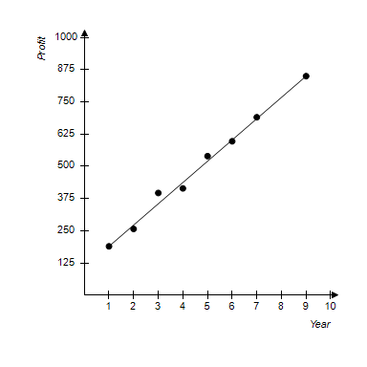
​
The scatterplot on the graph shows the profit of a small company in thousands for each year being open after 2000.

221. Interpret the meaning of the vertical intercept.
​
 | a. | In year 0, there was a profit of $75 | b. | In year 2000, there was a profit of $75,000
 | c. | In year 2000, there was a profit of $100 | d. | In year 2000, there was a profit of $100,000

222. Write the equation of the line that passes through the points and .
​
 | a. |  | b.
 | c. |  | d.

223. Rewrite the following equation in the general form of a line.
​
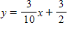
​
 | a. |  | b.
 | c. |  | d.

2003 | 21.5
2004 | 22.3
2005 | 23.4
2006 | 24.6

224. Graph the data on your calculator and find the equation that best fits the given points.
​
 | a. |  | b.
 | c. |  | d.

225. Solve for the indicated variable in the formula.
​
Area of a circle is . Solve for .
​
 | a. |  | b.
 | c. |  | d.

A real estate agent receives a salary of $13,000 plus 4% of her total sales for the year.

226. How many dollars worth of real estate does she need to sell in order to make $64,000 for the
year?
​
 | a. | $1,275,000 | b. | $51,000
 | c. | $127,500 | d. | $1,587,000

227. Write an equation that expresses the agent’s salary, , in terms of her total annual sales, .
​
 | a. |  | b.
 | c. |  | d.

2003 | 21.5
2004 | 22.3
2005 | 23.4
2006 | 24.6

228. Choose the window that will display the given data in a scatterplot on your calculator.
Let Years since 2000.
​
 | a. | ,  , | b. | ,  ,
 | c. | ,  , | d. | ,  ,

229. Write the equation for the line shown in the graph. Give your answer in slope-intercept form and use points that cross clearly on the graph.
​
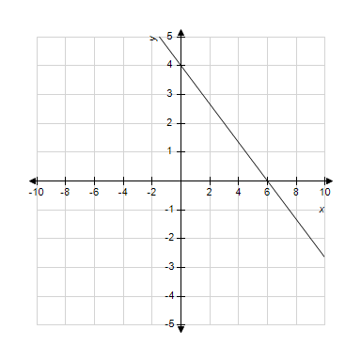
​
 | a. |  | b.
 | c. |  | d.

-5 | -5.5
-2 | -7.4
0 | -8.6
3 | -11

230. Graph the data on your calculator and find the equation that best fits the given points.
​
 | a. |  | b.
 | c. |  | d.

Air pollution in the United States has become a concern in recent years. The formula below models the sulfur dioxide emissions during a given year between 1970 and 1997.
​
​
In the formula, is the emission of sulfur dioxide in thousands of tons, and is the number of years after 1970; that is, on January 1, 1970.
(U.S. Environmental Protection Agency, National Air Quality and Emissions Trend Report.)
​

231. What was the emission of sulfur dioxide in thousands of tons in 1987?
​
 | a. | 24,046 thousand tons | b. | 23,651 thousand tons
 | c. | 23,256 thousand tons | d. | 22,861 thousand tons

232. Write the equation for the line shown in the graph. Give your answer in slope-intercept form and use points that cross clearly on the graph.
​
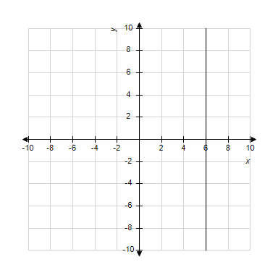
​
 | a. |  | b.
 | c. |  | d.

233. Write the equation of the line with the slope and passing through the point .
​
 | a. |  | b.
 | c. |  | d.

234. Determine if the following points pass through the same line, by determining if the slope is consistent.
​
-3 | 3
0 | -1
1
3 | -5
​
 | a. | they do not pass through the same line | b. | yes; slope
 | c. | yes; slope | d. | yes; slope

235. Write the equation of the line with the slope and passing through the point .
​
 | a. |  | b.
 | c. |  | d.

-5 | -5.5
-2 | -7.4
0 | -8.6
3 | -11

236. Give a reasonable -scale and -scale for the given data.
​
 | a. | , | b. | ,
 | c. | , | d. | ,

5.5 | 15
6.25 | 27
7.5 | 49
9.25 | 79

237. Graph the data on your calculator and find the equation that best fits the given points.
​
 | a. |  | b.
 | c. |  | d.

-5 | -5.5
-2 | -7.4
0 | -8.6
3 | -11

238. Choose the window that will display the given data in a scatterplot on your calculator.
​
 | a. | ,  , | b. | ,  ,
 | c. | ,  , | d. | ,  ,

Air pollution in the United States has become a concern in recent years. The formula below models the sulfur dioxide emissions during a given year between 1970 and 1997.
​
​
In the formula, is the emission of sulfur dioxide in thousands of tons, and is the number of years after 1970; that is, on January 1, 1970.
(U.S. Environmental Protection Agency, National Air Quality and Emissions Trend Report.)
​

239. In what year were sulfur dioxide emissions 29,576 thousand tons?
​
 | a. | 1972 | b. | 1982
 | c. | 1992 | d. | 2002

240. Determine without graphing whether the given two lines are parallel, perpendicular, or neither.
​
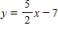
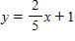
​
 | a. | parallel | b. | perpendicular
 | c. | neither

241. Solve for the indicated variable in the formula.
​
Volume of a pyramid is 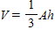. Solve for .
​
 | a. |  | b.
 | c. |  | d.

242. Write the equation of the line that passes through the points and .
​
 | a. |  | b.
 | c. |  | d.

243. Determine if the following points pass through the same line, by determining if the slope is consistent.
​
-4 | -11
-2 | -10
0 | -9
2 | -8
​
 | a. | they do not pass through the same line | b. | yes; slope
 | c. | yes; slope | d. | yes; slope

244. Which of the following is NOT a function?
​
 | a. |  | b.
 | c. |  | d.

​
The scatterplot on the graph shows the profit of a small company in thousands for each year being open after 2000.

245. In what year did the profits of the company break $500,000?
​
 | a. | 2002 | b. | 2005
 | c. | 2007 | d. | 2009

246. Determine without graphing whether the given two lines are parallel, perpendicular, or neither.
​
​
 | a. | parallel | b. | perpendicular
 | c. | neither

247. Which of the following is a function?
​
 | a. |  | b.
 | c. |  | d.

Hertz Truck Rentals offers a midweek special on all of their truck rentals. To rent a 15-foot truck for one day, it will cost $29.66 plus $0.68 per mile driven. Let be the cost of renting a 15-ft truck from Hertz for one day and driving the truck, , miles.

248. How much would it cost to rent a 15 ft truck from Hertz for one day if you were to drive it 118 miles?
​
 | a. | $199 | b. | $100.99
 | c. | $109.90 | d. | $190.90

Air pollution in the United States has become a concern in recent years. The formula below models the sulfur dioxide emissions during a given year between 1970 and 1997.
​
​
In the formula, is the emission of sulfur dioxide in thousands of tons, and is the number of years after 1970; that is, on January 1, 1970.
(U.S. Environmental Protection Agency, National Air Quality and Emissions Trend Report.)
​

249. In what year were sulfur dioxide emissions 20,096 thousand tons?
​
 | a. | 1985 | b. | 1986
 | c. | 1996 | d. | 1997

110 | -6.25
112 | -12
120 | -34.25
126 | -52

250. Choose the window that will display the given data in the scatterplot on your calculator.
​
 | a. | ,  , | b. | ,  ,
 | c. | ,  , | d. | ,  ,

251. Rewrite the following equation in the general form of a line.
​
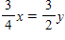
​
 | a. |  | b.
 | c. |  | d.

​
The scatterplot on the graph shows the profit of a small company in thousands for each year being open after 2000.

252. Approximate the profit of the company in 2008.
​
 | a. | $650,000 | b. | $700,000
 | c. | $750,000 | d. | $800,000

2.2 | 10
2.5 | 20
2.6 | 24
2.8 | 33

253. Graph the data on your calculator and find the equation that best fits the given points.
​
 | a. |  | b.
 | c. |  | d.

254. Determine without graphing whether the given two lines are parallel, perpendicular, or neither.
​
​
 | a. | parallel | b. | perpendicular
 | c. | neither

255. Which of the following is a function?
​
 | a. |  | b.
 | c. |  | d.

256. Write the equation for the line shown in the graph. Give your answer in slope-intercept form and use points that cross clearly on the graph.
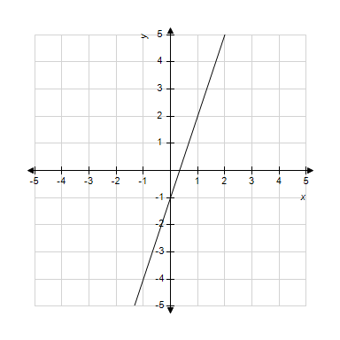
​
 | a. |  | b.
 | c. |  | d.

257. Determine if the following points pass through the same line, by determining if the slope is consistent.
​
1
2
3
4
​
 | a. | they do not pass through the same line | b. | yes; slope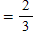
 | c. | yes; slope | d. | yes; slope

The elementary school expenditures, , in the U.S. in billions of dollars years past 1990 can be modeled by the equation:
​

258. When will the expenditures reach $500 billion?
​
 | a. | 2024 | b. | 2012
 | c. | 2014 | d. | 2023

5.5 | 15
6.25 | 27
7.5 | 49
9.25 | 79

259. Choose the window that will display the given data in the scatterplot on your calculator.
​
 | a. | ,  , | b. | ,  ,
 | c. | ,  , | d. | ,  ,

260. Write the equation of the line with the slope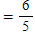 and passing through the point .
​
 | a. |  | b.
 | c. |  | d.

261. Determine without graphing whether the given two lines are parallel, perpendicular, or neither.
​
​
 | a. | parallel | b. | perpendicular
 | c. | neither

262. Write the equation of the line that passes through the points and .
​
 | a. |  | b.
 | c. |  | d.

​
The scatterplot on the graph shows the profit of a small company in thousands for each year being open after 2000.

263. Estimate the vertical intercept of the graph.
​
 | a. |  | b.
 | c. |  | d.

2.2 | 10
2.5 | 20
2.6 | 24
2.8 | 33

264. Give a reasonable -scale and -scale for the given data.
​
 | a. | , | b. | ,
 | c. | , | d. | ,

110 | -6.25
112 | -12
120 | -34.25
126 | -52

265. Give a reasonable -scale and -scale for the given data.
​
 | a. | , | b. | ,
 | c. | , | d. | ,

The worldwide sales from prescription drugs used in the treatment of the blood disorder hemophilia (in millions of $) is given in the table.

Year | Treatment Sales (in millions of $)
2001 | 2,584
2002 | 2,932.7
2003 | 3,264.7
2004 | 3,598.2

266. Using your graphical model, estimate the worldwide prescription drug sales for the treatment of hemophilia in 2005.
​
 | a. | $4,000 million | b. | $2.5 billion
 | c. | $3.5 billion | d. | $3,700 million

267. Rewrite the following equation in the general form of a line.
​
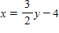
​
 | a. |  | b.
 | c. |  | d.

268. Determine without graphing whether the given two lines are parallel, perpendicular, or neither.
​
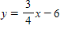
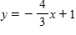
​
 | a. | parallel | b. | perpendicular
 | c. | neither

2.2 | 10
2.5 | 20
2.6 | 24
2.8 | 33

269. Choose the window that will display the given data in the scatterplot on your calculator.
​
 | a. | ,  , | b. | ,  ,
 | c. | ,  , | d. | ,  ,

270. Rewrite the following equation in the general form of a line.
​
​
 | a. |  | b.
 | c. |  | d.

271. Determine without graphing whether the given two lines are parallel, perpendicular, or neither.
​
​
 | a. | parallel | b. | perpendicular
 | c. | neither

272. Write the equation of the line that passes through the points and .
​
 | a. |  | b.
 | c. |  | d.

273. Rewrite the following equation in the general form of a line.
​
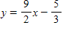
​
 | a. |  | b.
 | c. |  | d.

274. Solve for the indicated variable in the formula.
​
Angular acceleration is . Solve for .
​
 | a. |  | b.
 | c. |  | d.

275. Rewrite the following equation in the general form of a line.
​
​
 | a. |  | b.
 | c. |  | d.

276. Rewrite the following equation in the general form of a line.
​
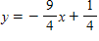
​
 | a. |  | b.
 | c. |  | d.

277. Write the equation of the line that passes through the points and .
​
 | a. |  | b.
 | c. |  | d.

The worldwide sales from prescription drugs used in the treatment of the blood disorder hemophilia (in millions of $) is given in the table.

Year | Treatment Sales (in millions of $)
2001 | 2,584
2002 | 2,932.7
2003 | 3,264.7
2004 | 3,598.2

278. What is a reasonable domain and range for the graphical model?
​
 | a. | Domain: ; Range:
 | b. | Domain: ; Range:
 | c. | Domain: ; Range:
 | d. | Domain: ; Range:

279. Rewrite the following equation in the general form of a line.
​
​
 | a. |  | b.
 | c. |  | d.

110 | -6.25
112 | -12
120 | -34.25
126 | -52

280. Graph the data on your calculator and find the equation that best fits the given points.
​
 | a. |  | b.
 | c. |  | d.

A real estate agent receives a salary of $13,000 plus 4% of her total sales for the year.

281. What will her pay be if she sells $822,000 worth of real estate for the year?
​
 | a. | $16,288 | b. | $341,800
 | c. | $52,280 | d. | $45,880

5.5 | 15
6.25 | 27
7.5 | 49
9.25 | 79

282. Give a reasonable -scale and -scale for the given data.
​
 | a. | , | b. | ,
 | c. | , | d. | ,

283. Solve for the indicated variable in the formula.
​
Solve for .
​
 | a. |  | b.
 | c. |  | d.

284. Determine if the following points pass through the same line, by determining if the slope is consistent.
​
-3 | 13
0 | 4
1 | 5
2 | 8
​
 | a. | they do not pass through the same line | b. | yes; slope
 | c. | yes; slope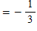 | d. | yes; slope

Hertz Truck Rentals offers a midweek special on all of their truck rentals. To rent a 15-foot truck for one day, it will cost $29.66 plus $0.68 per mile driven. Let be the cost of renting a 15-ft truck from Hertz for one day and driving the truck, , miles.

285. Find an equation for the cost of renting from Hertz.
​
 | a. |  | b.
 | c. |  | d.

286. Solve for the indicated variable in the formula.
​
Impulse is . Solve for .
​
 | a. |  | b.
 | c. |  | d.

287. Which of the following is NOT a function?
​
 | a. | Net sales years after 2000 | b. | spending in month in 2010
 | c. | salary for a teacher with years experience | d. | salary of a person years old

288. Write the equation for the line shown in the graph. Give your answer in slope-intercept form and use points that cross clearly on the graph.
​
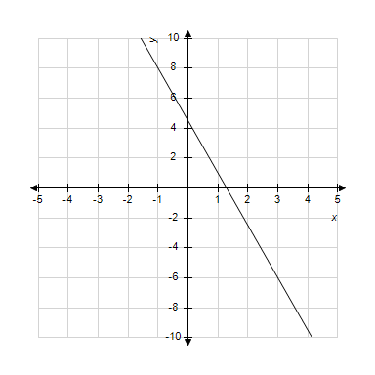
​
 | a. |  | b.
 | c. |  | d.

Answer Key
1. True

2. False

3. False

4. True

5. True

6. False

7. No

8. No

9. Yes

10. Yes

11. No

12. Yes

13. No

14. Yes

15. Yes

16. Yes

17. -12

18. 6

19. 60,380

20. 5,500

21. -20

22. -1

23. 3

24. 7

25. -11

26. -1.5

27. 61

28. 2,750,000

29. 1,545

30. 7,411

31. 518

32. 3,200

33. 12

34. 6

35. 20

36. 3

37. 69

38. 6,750

39. -2

40. 1988

41. 7,825

42. 290

43. 529,070

44. 65.5

45. 9

46. 4,072

47. 2005

48. 2005

49. Slope
-intercept 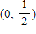

50.

51.

52.
Answers may vary.

53. Slope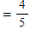
-intercept

54. Slope or Slope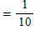
The total price of the business cards increases by $0.10 per card ordered.
​
When is negative. A person cannot order a negative number of business cards.

55. Answers will vary.
a)
b) If , then and
c) Domain: all real numbers
Range:
d) Vertical intercept
Horizontal intercept and

56. ​
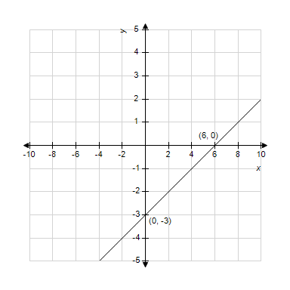
​

57.
The cost to produce 50 keychains is $72.50.

58.
Answers may vary.

59. Answers will vary for the table.
​
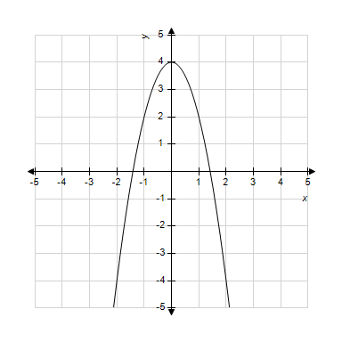
​

60.
Answers may vary.

61.

62. Slope
​
The total tuition paid increases by $275 per month.
​
When is negative. A child cannot attend preschool for a negative number of months.

63. Slope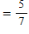
-intercept 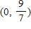

64. a.
​
b. -intercept
When the loan officer closes 0 loans in a month, she earns $1,850.
​
c. -intercept
When the loan officer closes approximately -12 loans, she will earn $0. This is a model breakdown.

65. In 1998, enrollment was approximately 14.5 million students.

66. a.
​
b. -intercept
It will cost $100 to order 0 T-shirts.
​
c. -intercept
It will cost $0 to order -25 T-shirts. This is a model breakdown.

67. ​
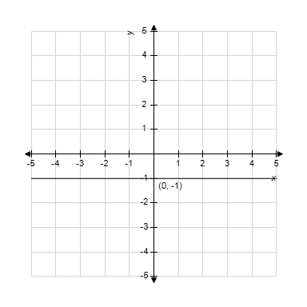

68.
​
In 1999, the population of Florida was about 15,697,000 people.

69. ​
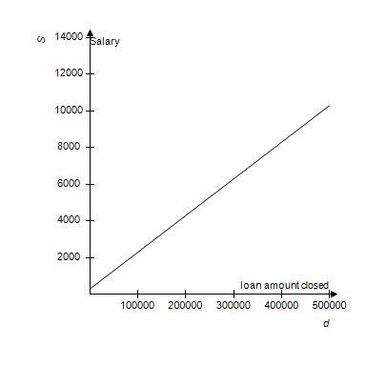
​

70.

71. 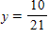

72.

73. a. Slope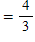
b. Increasing
c. 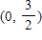 or
d. 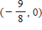 or
​

74. Slope
-intercept

75.
Answers may vary.

76. -intercept
​
-intercept
​
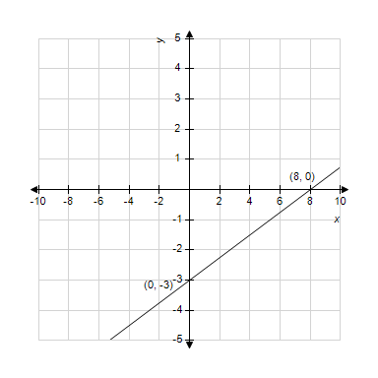
​

77. -intercept
​
-intercept
​
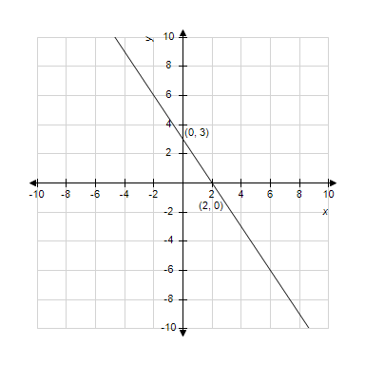
​
​

78. Slope
-intercept

79. ​
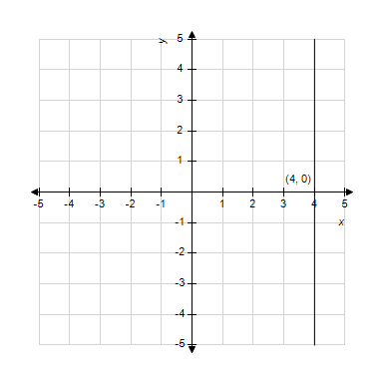
​

80. In the year 2000, the population of the Western U.S. population is 63.2 million people.

81. If , then .
In 1999, the profit of the company was $1 million.

82. a.
​
b. -intercept
If the sales clerk sells $0, she will earn $300 for the week.
​
c. -intercept
If the sales clerk sells -$7,500, she will earn $0 for the week. This is a model breakdown.

83.
Answers may vary.

84. Answers will vary for the table.
​
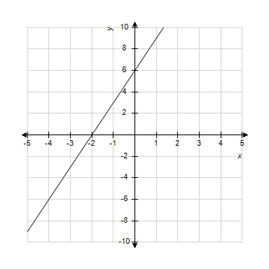
​
​
​

85. ​
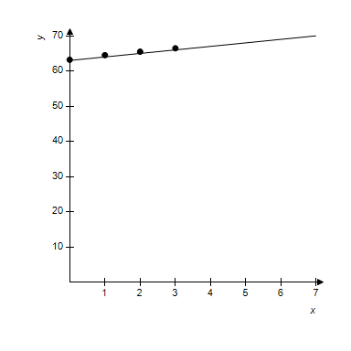

86. Answers will vary for the table.
​
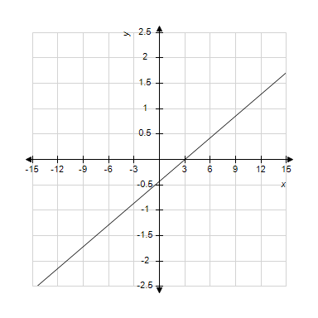
​

87. a)
b) If , then
c) Domain: all real numbers
Range: all real numbers

88. a. -intercept
If the loan officer closes $0 in loans, he will make $1,200 for the month.
​
b. -intercept
If a loan officer closes -$40,000 in loans, he will make $0 for the month. This is a model breakdown.

89. ​
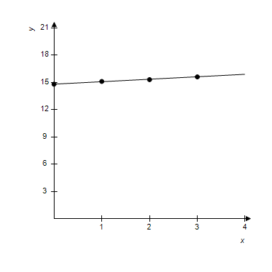
​

90.

91. If , then .
It costs $772.50 to produce 2,050 keychains.

92. ​
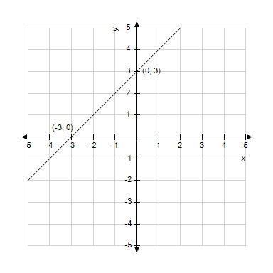
​

93. 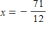

94. -intercept
​
-intercept: none
​
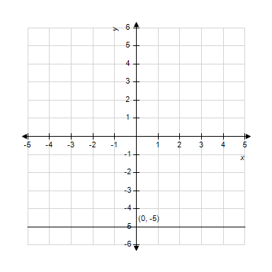

95.

96. a. Slope
b. Decreasing
c.
d. 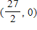 or
​
​

97. ​

98.
Answers may vary.

99. Answers will vary.
a)
b) If , then 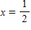
c) Domain: all real numbers
Range: all real numbers
d) Vertical intercept
Horizontal intercept

100. a. Slope
b. Decreasing
c.
d.
​

101. a. -intercept
It will cost $448 to rent a truck and drive it 0 miles.
​
b. -intercept
It will cost $0 to rent a truck if you drive it -1,120 miles. This is a model breakdown.
​

102. 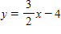

103. -intercept
​
-intercept
​
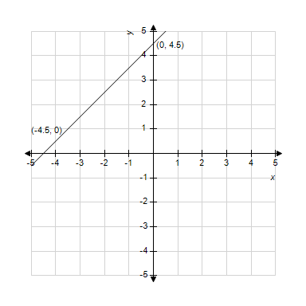

104.
Answers may vary.

105.

106. Answers will vary.
a)
b) If , and
c) Domain: all real numbers
Range:
d) Vertical intercept 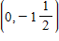
Horizontal intercept and
​

107. $87,987.50
Answers may vary.

108.

109. a. Slope
b. Decreasing
c.
d.
​
​

110. ​
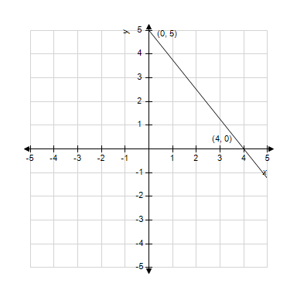
​

111. Answers will vary for the table.
​
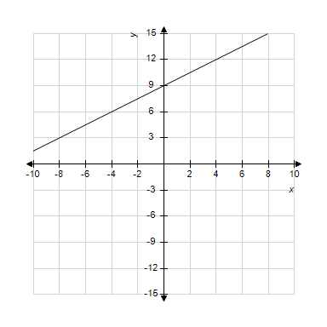
​

112.
Answers may vary.

113. Answers will vary for the table.
​
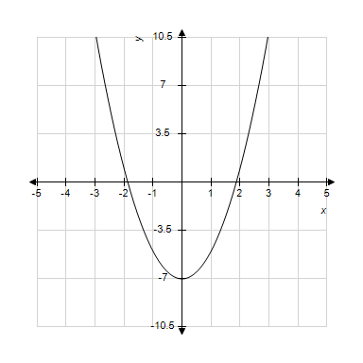
​

114. a.
​
b. Slope
For each year after 1990, the California population of children under five years old decreases by 0.07%.
​
c.
In 1990, the California population of children under five years old was 8%.
​
d.
In approximately the year 2104, the California population will contain 0% of children under five years old. This is a model breakdown.

115. 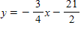

116. -intercept
​
-intercept
​
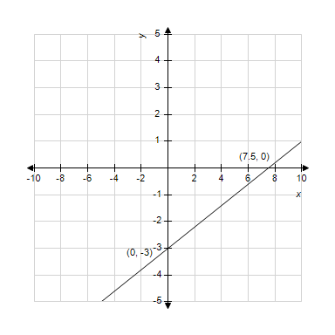
​

117. Slope
Each year the population of Florida increases by 327,000 people.
​

118.
The profit of the company in 2010 was $133 million.

119. Answers will vary for the table.
​
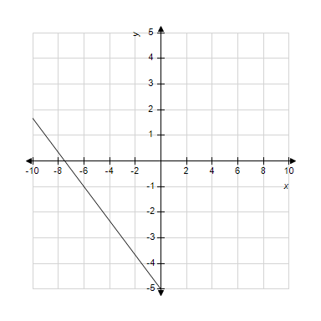
​

120. Slope
-intercept

121. -intercept
​
-intercept: none
​
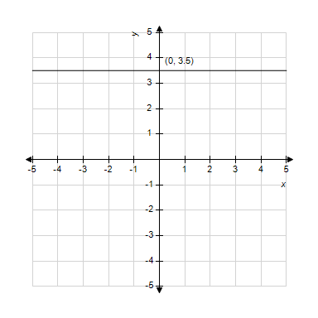

122.

123.
Answers may vary.

124. 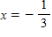

125. About 9 years.

126. a. -intercept
In the year 2000, the population of the United States was 281.74 million people.
​
b. -intercept
In approximately 1906, the population of the United States was 0. This is a model breakdown.

127. -intercept: none
​
-intercept
​

128. Tables will vary.
250 | 225
500 | 250
750 | 275
1,000 | 300
1,250 | 325

129. a.
​
b. Slope
For every loan that the loan officer closes he will make $250 more dollars.
​
c.
If the loan officer closes no loans in the month, then he will earn $1,500.
​
d.
If the loan officer closes -6 loans, then he will earn $0. This is a model breakdown.

130. ​
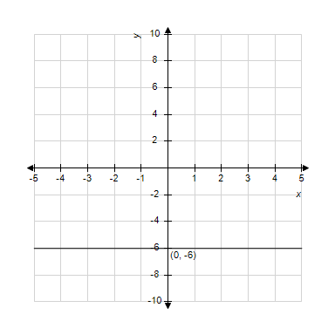
​

131. 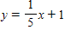

132. -intercept
It costs $55 to produce 0 keychains.

133.

134. a.
​
b. -intercept
0 minutes after the truck has started dumping the truck contains 8,500 lbs of fill dirt.
​
c. -intercept
85 minutes after the truck has started dumping the truck contains 0 lbs of fill dirt.
​

135. a. -intercept
In the year 2000, there were about 258 per 100,000 heart disease related deaths in the U.S..
​
b. -intercept
In approximately 1970, there were 0 per 100,000 heart disease related deaths in the U.S. This is a model breakdown.

136. $120,284.6 million in net sales.
About $120 billion in net sales.
Answers will vary.

137. :
:

138. Slope
-intercept

139. ​
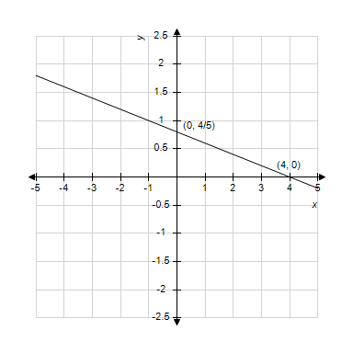
​

140. a. Slope
For each year after the first year a restaurant has been in business, 5.5% of the remaining restaurants fail.
​
b.
After the one year, 66% of restaurants are still in business.
​
c.
After 13 years (or 12 years after the first year in business), there are 0% of restaurants still in business. This is a model breakdown.

141. ​
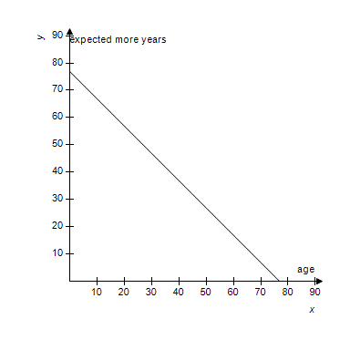

142.
Answers may vary.

143. ​
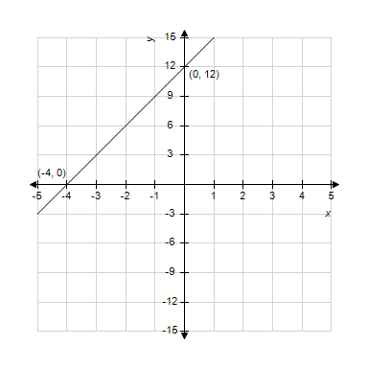

144. a. 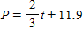
​
b. Slope
For each year since 2000, the percentage of families with children under 5 living below the poverty level increases by two thirds of 1%, or increases by 0.667%.
​
c.
In 2000, 11.9% of the California families with children under five were living below the poverty level.
​
d.
In 1982, 0% of the California families with children under five were living below the poverty level. This is a model breakdown.

145.

146. a. Slope
b. Decreasing
c.
d.
​

147. Slope
​
For each year a person lives, they are expected to live one less year.
​
For . For each year after 77 a person lives, they are expected to live a negative number of years more.

148. Tables will vary.
​
0 | 300
100,000 | 2,300
200,000 | 4,300
300,000 | 6,300
400,000 | 8,300

149.

150. In 2005, the newspaper circulation was approximately 52.5 million.

151. a. Slope
For each hour Nancy teaches, she makes $27 more.
​
b.
If Nancy taught no lessons in the whole semester, her profit would be -$950.
​
c.
If Nancy taught approximately 35 1-hour lessons, she would break even for the semester.
​
d. $3,910 profit for 180 hours total over the course of the semester.

152.
Answers may vary.

153. ​
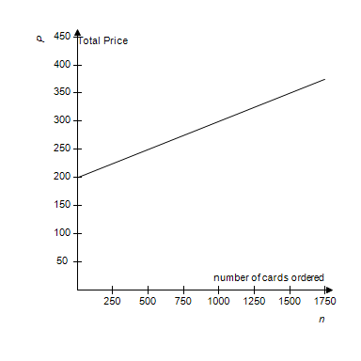
​

154. a)
b) If , then 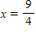
c) Domain: all real numbers
Range: all real numbers

155.

156. 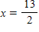

157. a. Slope
b. Increasing
c.
d. 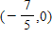 or
​

158.
Answers may vary.

159. Slope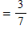
-intercept 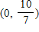

160.

161.

162. ​
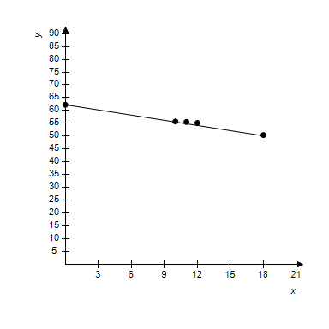
​

163. -intercept: none
​
-intercept
​
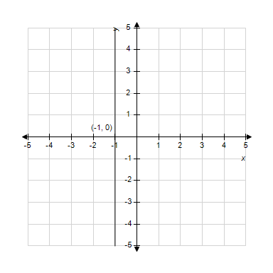

164. About 19,948,000 people.
​

165. ​
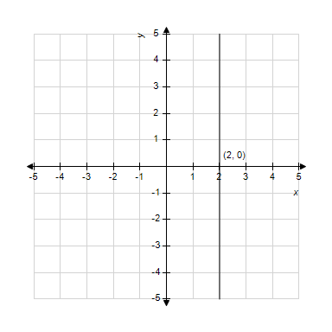

166.

167. -intercept
​
-intercept
​
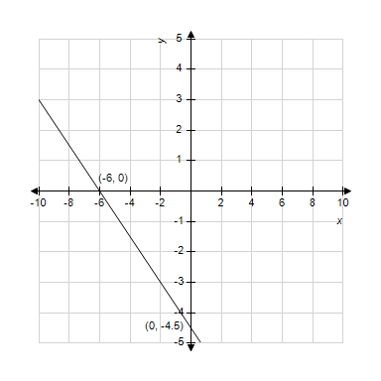
​

168. Answers will vary for the table.
​
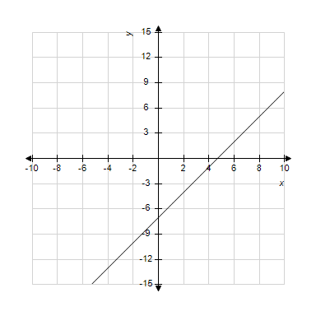
​
​

169.

170. Answers will vary.
a)
b) If , then
c) Domain: all real numbers
Range: all real numbers
d) Vertical intercept
Horizontal intercept

171. a)
b) If , then
c) Domain: all real numbers
Range: all real numbers

172. a.
​
b. -intercept
A non-California resident will pay $2,000 in tuition for 0 units.
​
c. -intercept
If a non-California resident takes -8 units, he would pay $0 in tuition. This is a model breakdown.

173. for

174. 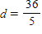

175. -intercept
​
-intercept
​
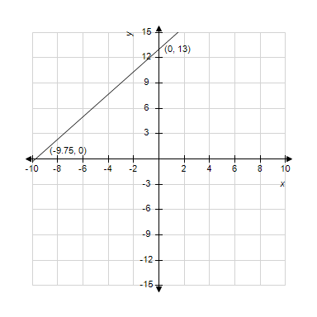

176. P-intercept .
In 2000, the profit of the company was $13 million.

177.

178.
Answers may vary.

179. Tables will vary.
2 | 900
4 | 1,450
6 | 2,000
8 | 2,550
10 | 3,100

180.
In 2000, the net sales for Home Depot was about $42.74 billion.

181. Slope
-intercept

182. ​
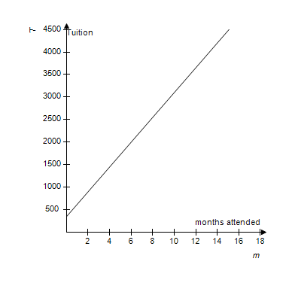
​

183. Answers will vary for the table.
​
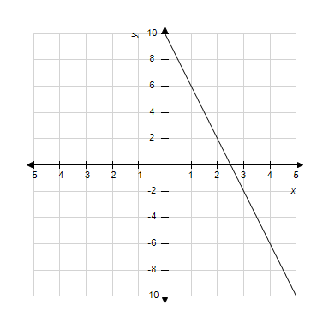
​

184. or
The loan officer earns $0.02 on every dollar in loans that he closes.
​
When d is a negative quantity. The loan officer cannot close on a negative amount of money.

185.

186. a)
b) If , then 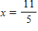
c) Domain: all real numbers
Range: all real numbers

187. a. -intercept
In the year 2000, there were 6,522 drug-induced deaths of women in the United States.
​
b. -intercept
In approximately 1995, there 0 drug-induced deaths of women in the United States. This is a model breakdown.

188. Slope
For each year of experience a teacher has, there is an increase of $2,737.50 in their salary.

189. Tables will vary.
​
0 | 77
10 | 67
20 | 57
30 | 47
40 | 37

190. Slope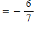
-intercept 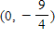

191. Domain:
Range:

192. Answers will vary.
a)
b) If , then
c) Domain: all real numbers
Range: all real numbers
d) Vertical intercept
Horizontal intercept

193.
Answers may vary.

194. Domain:
Range:
​
Answers will vary.

195.
In about 1951, the population of Florida was 0 people. This is a model breakdown.

196. Slope
Each year Home Depot’s net sales increase by $7,754.7 million.

197. ​
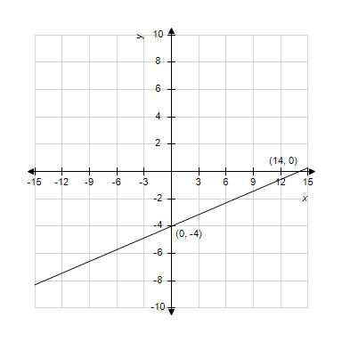

198. ​
​  Years since 2000, | Western U.S.  Population,  (in millions)
0 | 63.2
1 | 64.51
2 | 65.5
3 | 66.47
​

199. a)
b) If ,
c) Domain: all real numbers
Range: all real numbers

200. d

201. a

202. c

203. a

204. a

205. a

206. d

207. a

208. a

209. c

210. c

211. b

212. c

213. d

214. a

215. d

216. a

217. c

218. a

219. d

220. c

221. d

222. a

223. b

224. a

225. d

226. a

227. a

228. b

229. c

230. b

231. b

232. b

233. b

234. b

235. c

236. d

237. c

238. a

239. a

240. c

241. b

242. d

243. d

244. c

245. b

246. c

247. a

248. c

249. c

250. a

251. c

252. c

253. c

254. b

255. b

256. b

257. b

258. c

259. a

260. a

261. a

262. c

263. b

264. c

265. d

266. a

267. a

268. b

269. a

270. b

271. a

272. d

273. b

274. a

275. a

276. c

277. a

278. d

279. c

280. b

281. d

282. b

283. c

284. a

285. b

286. b

287. d

288. d

